
WILLUNGA HIGH SCHOOL
Uniform Order / Payment Form

Student's name: Mobile:

Description | Colour | Sizes |  |  |  |  |  |  |  |  |  |  |  |  |  |  |  | Price  (Inc GST & Logo)
TOP GARMENTS
Plain Relax Fit Polo Top | SIZE | 8 | 10 |  | 12 | 14 | S |  | M | L | XL |  | 2XL | 3XL |  | 5XL |  | $25.00
Plain Relax Fit Polo Top | Navy
Contrast Relax Fit Polo Top (with buttons) | SIZE | 6 | 8 |  | 10 | 1 2 | 14 |  | 16 | S | M |  | L | XL |  | 2XL | 3/5XL | $31.00
Contrast Relax Fit Polo Top (with buttons) | Navy/White
Plain Fitted Polo Top Poly/Cotton | SIZE | 8 | 10 |  | 12 | 14 | 16 |  | 18 | 20 | 22 |  | 24 |  |  |  |  | $25.00
Plain Fitted Polo Top Poly/Cotton | Navy
Contrast Fitted Polo Top  (v neck/ no buttons) | SIZE | 8 | 10 |  | 16 | 18 | 20 |  | 22 | 24 |  |  |  |  |  |  |  | $31.00
Contrast Fitted Polo Top  (v neck/ no buttons) | Navy/White
Fleece Jumper (red collar insert) | SIZE | 8 | 10 |  | 12 | 14 | 16 |  | S | M | L |  | XL | 2XL |  | 3XL | 5XL | $55.00
Fleece Jumper (red collar insert) | Navy
Rugby Jumper | SIZE | 10 | 1 2 |  | 14 | 16 | S |  | M | L | XL |  | 2XL | 3XL |  | 4XL |  | $74.00
Rugby Jumper | Navy
Razor Zip Jacket with Concealed Hood | SIZE | 8 | 10 |  | 1 2 | 14 | XS |  | S | M | L |  | XL | 2XL |  | 3XL | 5XL | $51.00
Razor Zip Jacket with Concealed Hood | Navy/White
BOTTOM GARMENTS
Leisure Pant | SIZE | 10 | 1 2 |  | 14 | XS | S |  | M | L | XL |  | 2XL | 3XL |  | 5XL |  | $40.00
Leisure Pant | Navy
Tartan Dress | SIZE | 4 | 6 |  | 8 | 10 | 12 |  | 14 | 16 | 18 |  | 20 | 22 |  | 24 |  | $75.00
Tartan Dress | Blue
Tartan Pleat Skirt | SIZE | 4 | 6 |  | 8 | 10 | 12 |  | 14 | 16 | 18 |  | 20 | 22 |  | 24 |  | $56.00
Tartan Pleat Skirt | Blue
Midford Pant | SIZE | 8 | 8A |  | 10 | 10A | 12 |  | 12A | 14 | 14A |  | 16 | 16A |  |  |  | $55.00
Midford Pant | NAVY
Stretch Straight Leg Fitted Pant | SIZE | 12 | 14 |  | 16 | 18 | 20 |  | 22 | 24 | 26 |  |  |  |  |  |  | CLEARANCE  $20
Stretch Straight Leg Fitted Pant | Navy
LW Reid Relax Fit  Navy Pant | SIZE | 8 | 10 |  | 12 | 14 | 16 |  | S | M | L |  | XL | 2XL |  | 3XL |  | CLEARANCE  $20
LW Reid Relax Fit  Navy Pant | Navy
Elastic Waist  Microfibre Shorts | SIZE | 8 | 10 |  | 12 | 14 | 16 |  | S | M | L |  | XL | 2XL |  | 3XL | 5XL | $22.00
Elastic Waist  Microfibre Shorts | Navy
HEAD WEAR
Bucket Hat | SIZE |  |  | S |  |  |  |  |  |  |  |  |  |  |  |  |  | $15.00
Total Order Amount $

Qkr! App Only

Willunga High School Uniform
Available for purchase from our school

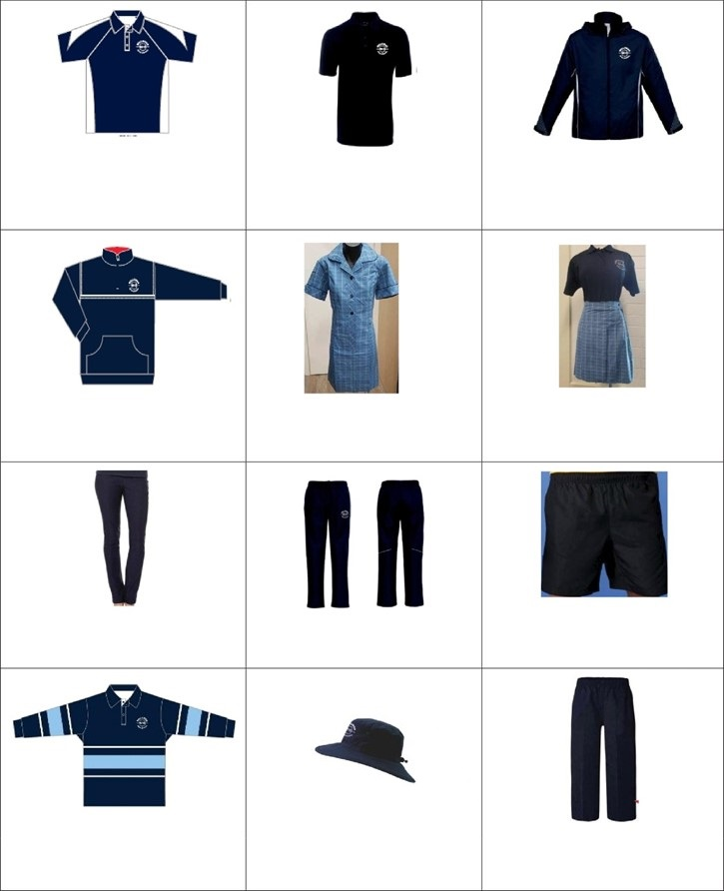

Premier Contrast Polo Top
Youths Size: 1 2 to 16
Adults Size: XS to 3XL + 5XL
V Neck Fitted Adults Size: 16 to 24

1/4 Zip Collared Fleece Jumper
Size: 3XS to 5XL

Stretch Straight Leg Fitted Pant
Size: 4 to 26

Rugby Top
Size: 12 to 16Y & S to 4XL

Plain Polo Top - Navy
Youths Size: 10 to 14
Adults Size: S to 5XL
Fitted Size: 8 to 24

Tartan Dress
Size: 6 to 24

Leisure Pant
Size: 12 to 14Y & XS to 5XL

Bucket Hat - Size: S

Razor Zip Jacket with Concealed Hood
Youths Size: 10 to 14
Adults Size: XS to 3XL + 5XL

Tartan Skirt
Size: 6 to 24

Elastic Waist Short
Adult Size: S to 3XL + 5XL
Youth Size: 8 to 16

Elastic Waist Relaxed Fit Pant
Size: 6 to 16Y & S to 2XL
PRICE INCLUDES GST AND SCHOOL LOGO WHERE APPLICABLE

